Federal Health Information Model Concept of Operations

**Prepared by:**

**Federal Health Architecture**

**August 30, 16**

Contents

Executive Summary 3

Introduction and Scope 3

What is an Information Model? 3

Federal Health Information Model 5

FHIM Modeling Governance Process 8

FHIM Capabilities 9

FHIM Usage 11

Summary 16

Citations 17

# Executive Summary

This Concept of Operations (CONOPS) document provides an overview, contents, and usage of the Federal Health Information Model (FHIM) by the Federal Health Architecture (FHA) federal partner organizations such as the Department of Veterans Affairs (VA), Department of Defense (DoD), Defense Health Agency (DHA), Federal Drug Administration (FDA), and Office of National Coordinator (ONC).

Based on the resources analyzed to develop the CONOPS, it is found that currently the FHIM is used for business information model updates, data standards establishment and alignment, data harmonization, data vocabulary, and new data model references by federal agencies such as the VA, DHA, FDA, ONC, and others. The FHIM provides a basis for information architecture within federal agency enterprise architecture (EA) practice as well as a single source of semantics (structure and terminology) to enable health information exchange.

The FHIM provides agency architects with information models of higher-level specifications with information on model attributes, support data requirements and properties, relationships, and the operations that can be performed on them.

# Introduction and Scope

FHA is an e-Government Line of Business (LOB) initiative designed to bring together the decision-makers in federal health information technology (IT) for inter-agency collaboration. The goal of this initiative is to achieve effective health information exchange, enhanced interoperability among federal health IT systems, and efficient coordination of shared services. FHA also supports federal agency adoption of nationally recognized standards and policies for efficient, secure health information exchange.

The scope of this CONOPS document is limited to providing a high-level description of the FHIM and its contents, its modeling and operating, and its past, present, and future planned usage by federal and non-federal agencies.

## What is an Information Model?

According to TechNet, an “*Information model is a collection of data types that describe a tool, application, data structure or information system*.” [1]An information model illustrates various types of information that are required to describe a domain that is being modeled. [2] Depending on the user, information models can have multiple uses; designers use information models to describe the model environment, whereas operators use them to understand the modeled objects. Similarly, implementers use information models as a guide to the functionality that gets described and coded in data models. Data models provide the definition and format of data. Figure 1 below shows that data models are defined at a lower level of abstraction than information models, which are protocol neutral and serve as an abstract model for designers and operators.[3]

|  |  |
| --- | --- |
|  | 🡪Information Model: Conceptual/abstract model for designers and operators |
| 🡪Data Model: Concrete/Detailed model for implementers |

**Figure 1. Information model and data model hierarchy[4]**

Classes, relationships, and properties are the building blocks of information models. A class in an information model represents entities and defines the characteristics of objects. A relationship in an information model defines a set of criteria that describes how two objects are related. A property defines attributes and value for an object.[5]

An example of an information model is shown in Figure 2. The model used in the example represents the information exchanged during the course of providing health services through a public health event in a community. The boxes in the figure represent the classes and object and relationships are established as they are linked together through the lines.

Simple visual techniques such as boxes and lines are used to simplify the meaningful rules and relationships between the information or data.[6]

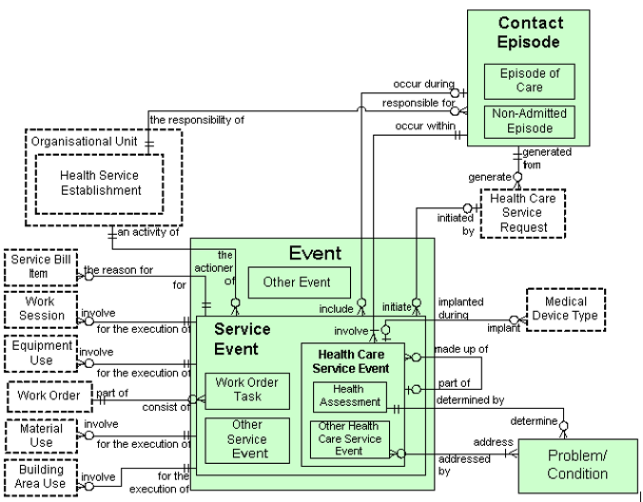

**Figure 2. Information Model representing information exchange during the course of providing health services to a patient[7]**

# Federal Health Information Model

Assuring high-quality care through data standardization depends on developing and maintaining effective and efficient health information interchange and intercommunication between care delivery organizations. Despite numerous standards development organizations (SDO) existing within the health industry, standards initiatives for health care have not always been well-coordinated and harmonized. There are notable overlaps in information modeling, messaging, image formats, vocabularies, and security.[8]

FHA initiated the FHIM in 2009 on behalf of their federal partners in an effort to develop a standard health information model among federal agencies. One of the goals of the FHIM is to serve as an information model harmonized across all FHA partners that could be used as the information or data layer in an agency’s EA.[9]

The FHIM was built in partnership with the participating federal agencies. It was developed to be the single and authoritative source of information for applicable health information technology standards. The FHIM allows information such as medical histories, enrollment information, provider information, procedures, prescriptions, etc., to be better standardized across participating federal agencies, specifically the DoD, VA, CDC, FDA, ONC, and NIST. Because the FHIM is a platform independent information model developed in collaboration with the federal agencies, it is also intended to harmonize health related information content across federal partners and standards organizations to make it possible that standards-based solutions work as intended.[10] As an example, modeling of vital signs such as blood pressure through the FHIM includes standard classifiers and common properties such as abstractbloodpressureobservation, bloodpressurecufffsizequalifier, bloodpressurediastolicendpoint, bloodpressureobservation, etc., as seen in Figure 3, a section of the blood pressure vital sign FHIM model.

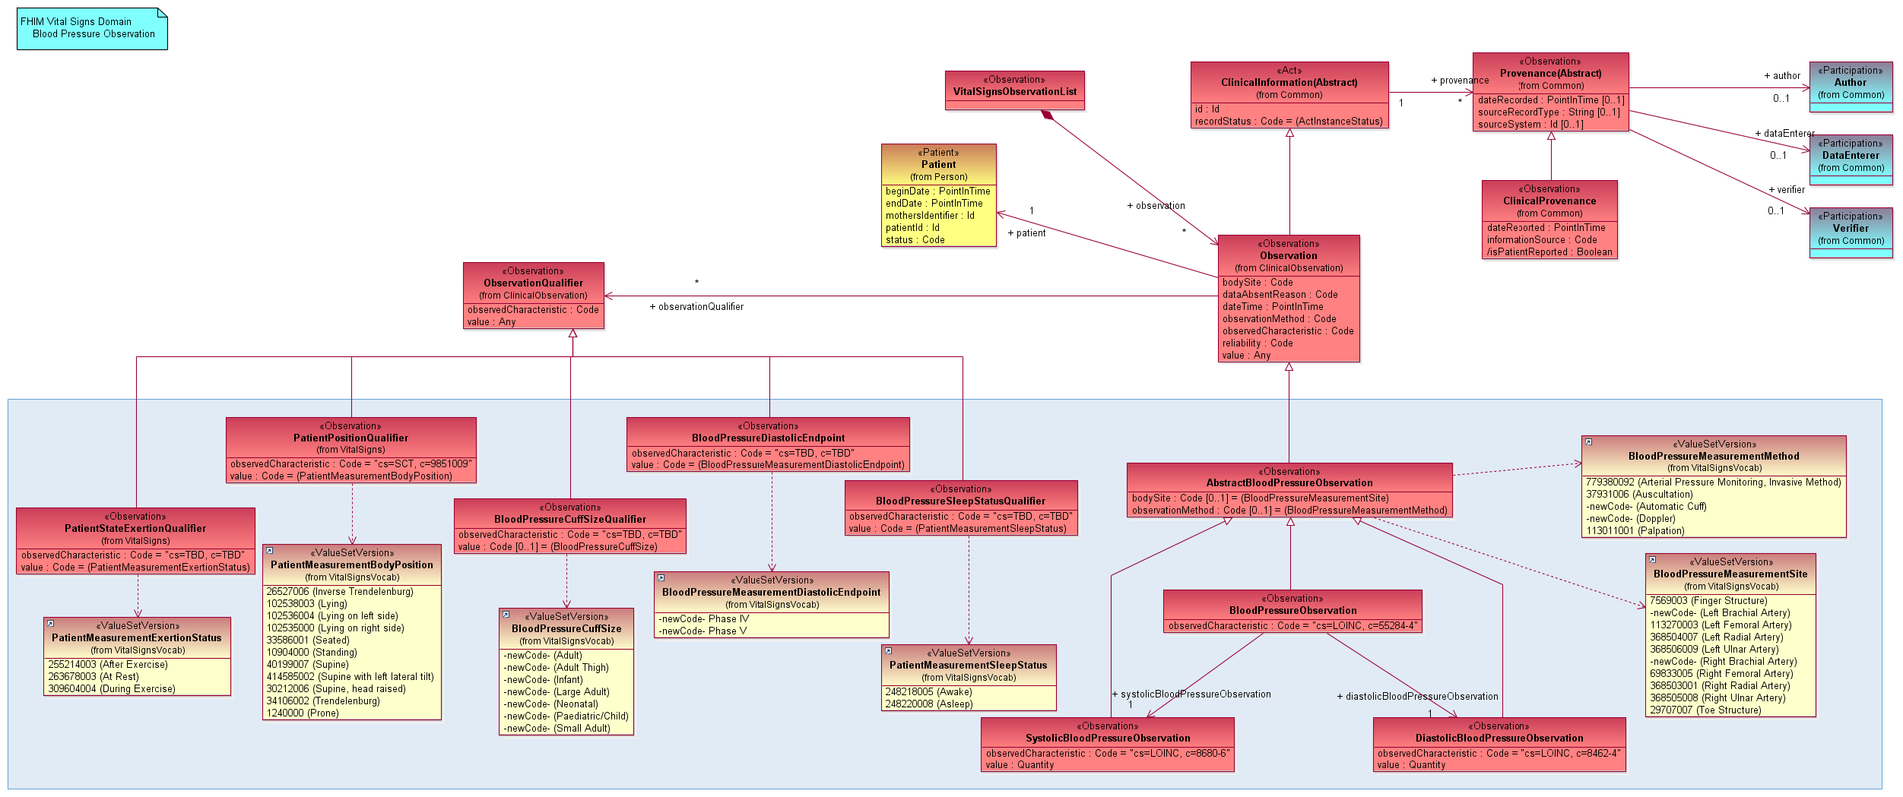

**Figure 3. FHIM Vital Signs Domain – A Section of the Blood Pressure Observation**

FHIM supports interoperability requirements for the FHA’s federal partners by identifying common data to enhance collection, sharing, and use of critical information between federal agencies and private sector healthcare organizations. Figure 4 depicts the information interoperability alignment framework developed for clinical data exchange between the VA and DoD.

The framework’s nine levels are grouped into three information types: data, transport, and security[11]. The FHIM applies to the “Data – Information model” and “Data – Terminology Models” levels where domain objects are modeled and relationships are established.

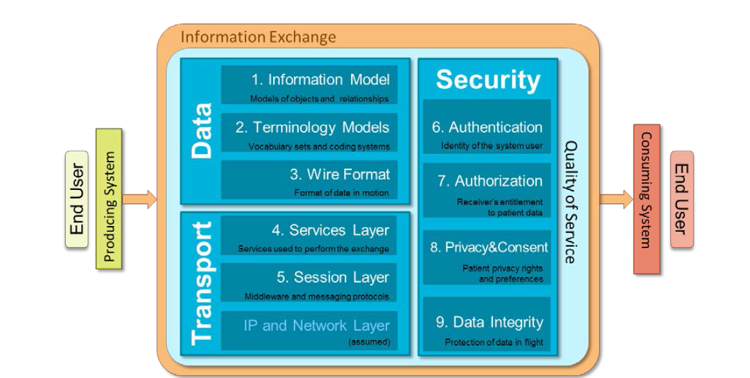

**Figure 4. Levels of Alignment for Information Interoperability**[12]

The FHIM aligns well with the FHA Strategic Plan Revised Draft dated November 29, 2012. Specifically, FHIM aligns with Goal 2, which is to “Encourage adoption of interoperability specifications, resulting in active data exchange in the federal health community”.

The dual focus on generating implementation guides, as well as supporting EA work, aligns with the following objectives in the strategy:[13] Objective 2.1: “Improve exchange of Health Data among the Federal Government (…)” and Objective 2.2: “Encourage Adoption of Interoperability Specifications (…)”.[14]

The FHIM model structure consists of information domains, which represent a group of related information. The status of these health information domains is represented by the Figure 5. The domains are color-coded to indicate the status of completion.

Domains which have not yet been modeled are represented in gray, purple color indicate that the domain is in-progress, and domains that are complete are indicated by color green.[15]

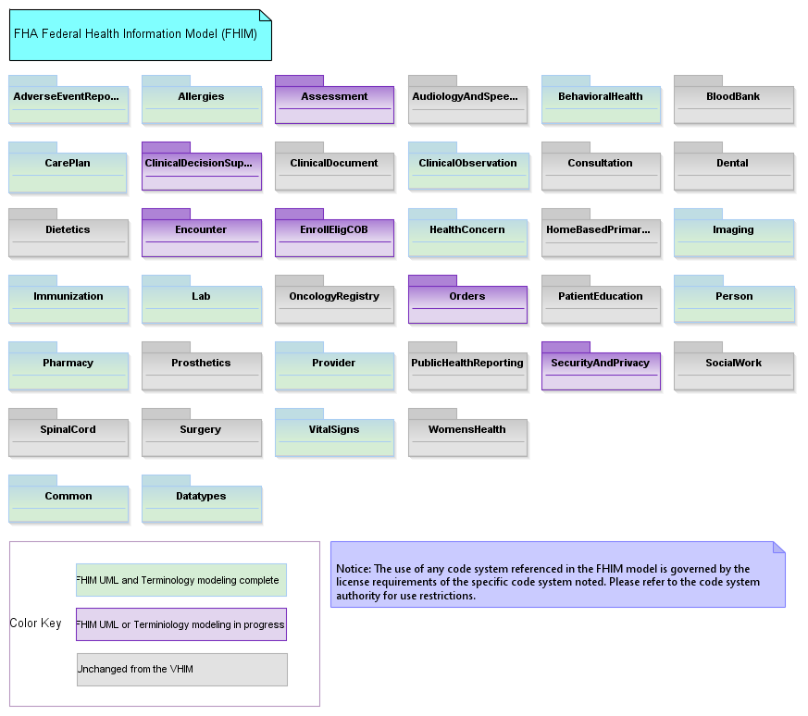

**Figure 5.** **FHIM Domains and their Completion State[16]**

Further information on the FHIM domains modeling and statuses, modeling style guide, and terminology modeling guide can be found at <http://www.fhims.org/links.html>.

## FHIM Modeling Governance Process

The FHIM fact sheet[17] lays out the modeling process for the FHIM. The FHIM modeling governing process as described in the modeling process fact sheet is summarized in graphical form in Figure 6, and involves seven stakeholders: FHA Managing Board; FHIM manager; lead domain modeler; FHIM modeling team; federal partners; and terminology team.

There are currently 36 different FHIM information domains. This number is expected to increase in the future as new information is identified during the modeling of the remaining domains. For a domain to be modeled, it is prioritized by the managing board based on the need of the federal partners, who bring their use cases and information requirements to the effort. The prioritized domain is then scheduled to be modeled by the FHIM manager who identifies the modeler and the modeling team. The lead domain modeler harmonizes the FHIM baseline with the existing interoperability standards and the FHIM modeling team identify the SMEs. The lead domain modeler and the FHIM modeling team work together to identify and model key use cases and confirm or modify the draft elements. The FHIM modeling team takes the lead to publish domain for review, once it has been shown to meet quality requirements.

Federal partners review the published domain and make any necessary comments or suggestions. Based on the received comments and feedback, the FHIM modeling team updates the domain and publishes the comment dispositions. The FHIM modeling team then publishes the domain.[18]

Further information on the detail modeling process and its governance can be found at [http://fhims.org/content/420A62FD03B6_root.html](http://fhims.org/content/420A62FD03B6_root.html%20%20)

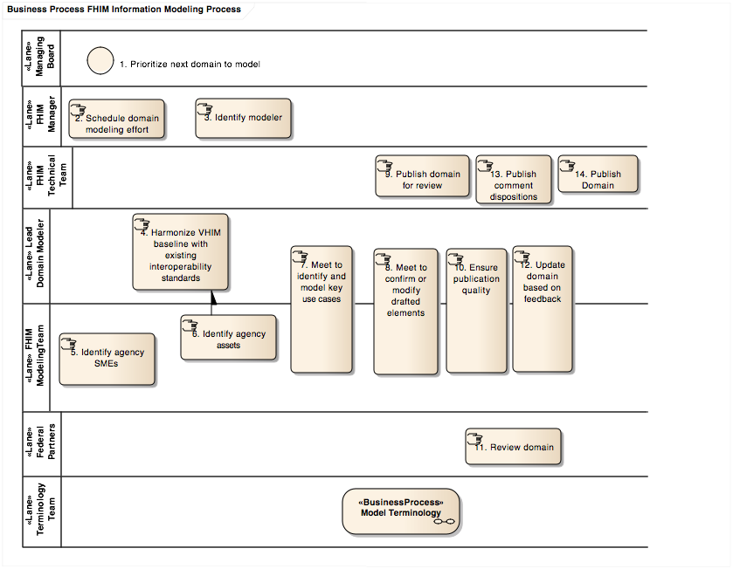

**Figure 6. FHIM Information Modeling Process[19]**

## FHIM Capabilities

In an earlier assessment of the FHIM by MITRE, “*Results of the Assessments of the FHIM (2012)*”, [20]one of the capabilities described is the ability to build and maintain platform independent models, which increases the efficiency of creating models without considerable rework as technologies evolve and the semantics of the domain changes. Further explanation of this FHIM capability can be found in the assessment report.

FHIM capabilities as mentioned by military heath system (MHS) users describe FHIM as a high-level conceptual model able to harmonize requirements from various federal interoperability use cases[21]. As shown in Figure 7, FHIM, with the aid of implementation and modeling tools such as MDHT and MDMI, is capable of providing information to support the generation of design artifacts such as implementation guides to create or validate specifications. Some of the major capabilities of FHIM listed as it relates to MHS is providing the structure, standards, terms (nouns), definitions, and data set relationship logic for the types of data (i.e., metadata) within the scope of the MHS data.

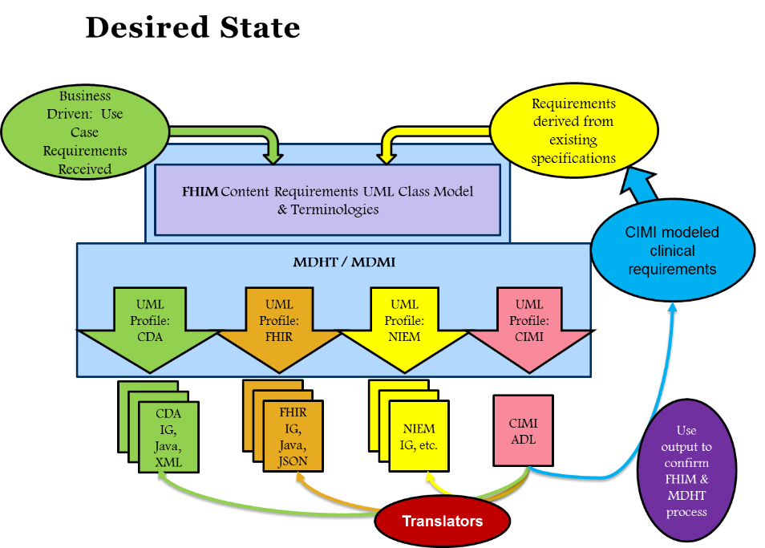

**Figure 7.** **High-level FHIM/MDHT Concept[22]**

FHIM is capable of serving as the common authoritative enterprise-wide description of the kinds of data required to operate the MHS and is independent of chosen database technology used to implement them.

The FHIM is capable of bridging the gap between the executive/business data requirements and technology-constrained databases.[23]

Other FHIM capabilities listed by FHIM subject matter experts include its ability to align with standards and terminologies such as HL7, SNOMED, LOINC, RxNorm, and NCPDP, as they make advances and evolve. Similarly, FHIM has the capability to align and update itself to implementation resources such as FHIR, and C-CDA, as well as to initiatives led by ONC such as the clinical quality framework (CQF), structured data capture (SDC), and data access framework (DAF), etc.[24]

# FHIM Usage

FHIM has evolved into a comprehensive model that has successfully integrated with and uses model-driven health tools to generate implementation artifacts (including guides and standards) and healthcare domains in the Clinical Document Architecture (CDA) and National Information Exchange Model.[25] To date, FHIM has successfully modeled nearly 85 percent of all the exchanged healthcare information .

The FHIM Model Driven Architecture (MDA) Implementation Process Guide, available at FHIM’s official website (<http://fhims.org/content/420A62FD03B6_root.html>) illustrates how implementers and users can reuse FHIM contents and classes of data to create implementation guides for specific interoperability standards using a generic or logical set of constraints.

As shown in Figure 8, the high level steps of FHIM implementation include documenting the information required for exchange in the FHIM, defining terminologies and value sets for coded data attributes in the FHIM vocabulary model, following the MDA process guide to produce a draft implementation guide, pilot testing the draft implementation and submitting the draft implementation guide to a standards developing organization (SDO)[26].

Further details on each of these steps can be found at the FHIM official site <http://fhims.org/content/420A62FD03B6_root.html>.

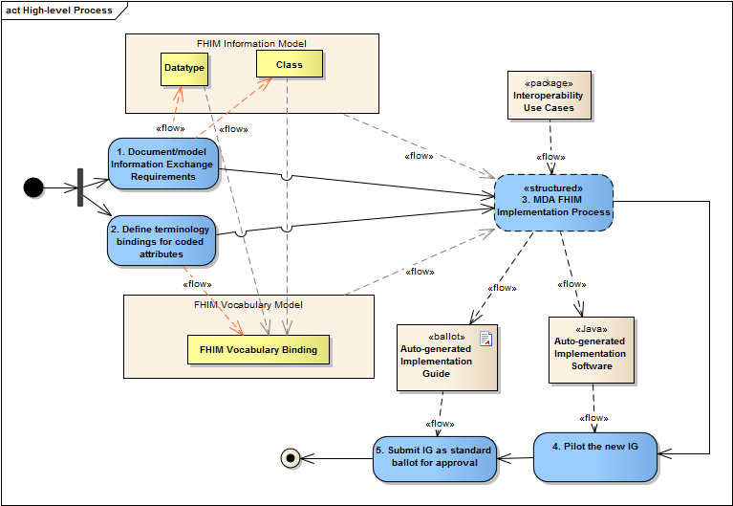

**Figure 8. High Level steps describing the FHIM Implementation Process[27]**

According to the report “Enhancing Health Information Exchange with the FHIM” [28] developed by The Open Group in April 2015, FHIM has been commended for cataloging key shared information exchange needs based on “real-world” use-case scenarios in a structured model populated with consensus-based industry standards.

The report also emphasizes that FHIM automates the production of implementation tools and artifacts and is able to provide an audit trail of decisions made throughout the process of building the information model. The report points out that relating FHIM to other major interoperability efforts can be highly useful and would lead to enabling the boundary-less information flow.

Federal and non-federal organizations and groups have implemented FHIM, and are considering future implementations.

In the FHIM usage example shown in Figure 9, a harmonized marital status data model was created by referencing the FHIM and using MHS source data requirements for a new electronic health record (EHR) system. The FHIM was also used to map across the MHS data dictionaries for Armed Forces Health Longitudinal Technology Application (AHLTA)/ Central Data Repository (CDR), Composite Health Care System (CHCS), and Essentris.[29]

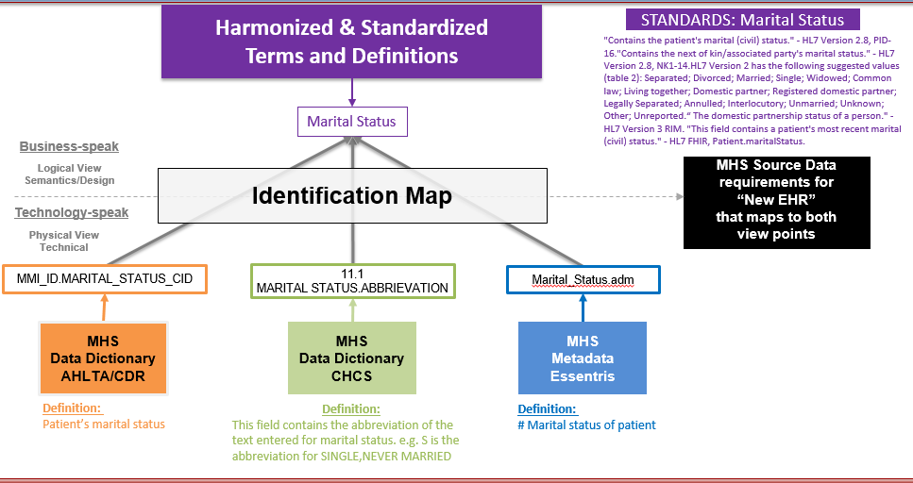

**Figure 9.** **Mapping of Harmonized Data Model Used in MHS[30]**

Table 1 lists major stakeholders for FHIM, either drivers or contributors to the development and maturity of the FHIM information model. Federal partners include, but not limited to, the Defense Health Agency and Military Health System, VA Health Business Information Model team; SSA and CMS identity, and other initiatives; NCI cancer informatics program; and FDA data standards program.

The report by the Open Group indicates that other major non-federal contributors and FHIM advocates include the Clinical Information Modeling Initiative (CIMI); standards organizations such as HL7, ASTM, NCPDP, RxNorm, HITSP, DICOM, and X12; and federal standards committees.[31]

**Table 1. Past, Present and Planned Future Usage of FHIM by Federal and Non-Federal Organizations**

| **Federal and Non-Federal Organizations** | **Past and Present Usage of FHIM** | **Future/Planned Usage of FHIM** |
| --- | --- | --- |
| **Department of Veterans Affairs (VA)** | According to VA personnel:[32]   * The FHIM Informs the VA Business Information Model (BIM). VA Health segment information modeling is represented in the BIM which leverages and strives to coordinate its content with the FHIM. * FHIM Ensures VA work remains synchronized with other federal agencies whose data modelers also reference the FHIM. * FHIM is referenced prior to any new VHA information modeling activity. | According to VA personnel: [33]   * Business Information Requirements for current and future initiatives are represented in the BIM * The initiatives are   + The VHA Virtual Patient Record   + Care in the Community Program   + Vista Modernization * Vista EHR system plans to use FHIR as a standard for health systems interoperability. |
| **The Defense Health Agency (DHA) & Military Health System (MHS)** | According to DHA personnel: [34]   * DHA is using FHIM to drive several of the data and standards requirements and provide the data definitions and standards. * The FHIM is used to establish design models, standards, and common entity attributes to map A.C.E. legacy systems to FHIM and MHS DIV-1 and DIV-2 models for new EHRs. * The FHIM is considered as the authoritative federal health data reference model. | According to DHA personnel:[35]   * FHIM will continue to be used to establish design models, standards, and common entity attributes to map data from A.C.E. legacy systems to MHS DIV-1 and DIV-2 models. * Interoperability of the new EHR will be based on the MHS Conceptual model, which contains the FHIM and imports it on each FHIM update. * FHIM is tied to modeling and subsequent development around MHS Genesis program. |
| **Food & Drug Administration (FDA)** | According to FDA personnel: [36]   * FDA currently works with FHIM initiatives to ensure federally recognized and mandated data standards align with FDA standards. | No future plans identified |
| **Office of National Coordinator (ONC)** | According to ONC personnel:[37]   * The FHIM is offering value to and being referenced by the Quality Improvement Core (QI CORE) initiative along with other models such as the Clinical Information Modeling Initiative. * ONC and National Institute of Science and Technology (NIST) use code generated by Model Driven Health Tools (MDHT) referencing the FHIM to test C-CDA conformance claims. | No future plans identified |
| **Interagency Program Office (IPO)** | The Clinical Interoperability Scenario (CIS) teams reference the Domain tables and models provided by the ONC and FHIM.[38] | No future plans identified |
| **The National Library of Medicine (NLM) & Value Set Authority Center (VSAC)** | FHIM is an active contributor to NLM VSAC-produced official versions of vocabulary value sets contained in the Clinical Quality Measures database.[39] | No future plans identified |
| **HL7 Clinical Information Modeling Initiative (CIMI) & Common Logical Information Model (CLIM)** | FHIM defines healthcare domains and high-level information-exchange classes (a.k.a. entities) in those domains; and where, FHIM classes are the context for CIMI Clinical Modeling Patterns constrained into Detailed Clinical Models (DCM).[40]  The FHIM profile and DCMs are collectively referred to and will be balloted as the CIMI curated CLIM.[41] | No future plans identified |
| **DaVita** | DaVita uses FHIM in their effort to consolidate and modernize health information systems.[42] | No future plans identified |

# Summary

This CONOPS provided an overview of the FHIM, including its design and specifications, modeling steps and high level overview and requirements for implementation, if an agency wants to use FHIM in their organization. The CONOPS document also listed known past, present, and planned future usage of the FHIM in federal and non-federal organizations. The usage information presented in this CONOPS document described how federal partners have used the FHIM and how the partners propose to use the FHIM in the future to increase their health IT information exchange needs.

At present, FHIM is used for business information model updates, data standards establishment and alignment, data harmonization, data vocabulary, and new data model references by such federal agencies as the VA, DHA, CDC, FDA, and ONC. The FHIM provides a basis for information architecture within federal agency EA practice, as well as potentially providing a single source of semantics (structure and terminology) to advance interoperability.

The FHIM provides agency architects with information models of higher-level specifications. Because FHIM is an information model, it provides information on domain properties, relationships, and the operations that can be performed on them. Federal agencies are planning to use the FHIM in health information exchange data standards, and in their efforts to establish design models and attributes, support data requirements, and advance new model development.

# Citations

**Documents:**

1. Federal Health Information Model (FHIM) Integration with the National Information Exchange Model (NIEM), Whitepaper, Release 1.0 V5, ONC, 2011 (FHIM_NIEM_Whitepaper_4_7_2011V5)
2. Results of the Assessments of the Federal Health Information Model (FHIM), Version 1, Prepared for FHA by MITRE, 2012 (Results of the Assessments of the FHIM – Version 1 (MITRE 2012))
3. Evaluation of the Federal Health Information Model (FHIM), Interim Observations and Questions for FHA, Prepared for FHA by The Open Group Healthcare Forum, 2014 (Evaluation of the FHIM: Interim observations and Questions for FHA)
4. FHIM: A Business Perspective, Prepared by FHA, 2016 (FHIM Value Proposition – A business focus – 20160325)
5. Enhancing Health Information Exchange with the FHIM, White Paper, Prepared by The Open Group Healthcare Forum, 2015 (Enhancing Health Information Exchange with the FHIM (2015))
6. VHA Business Information Architecture, How VHA Business Information Architecture Leverages and Contributes to the Federal Health Information Model, VHA BIA Unit, 2013 (VHA FHIM Use Case PowerPoint)
7. Overview of Military Health System Federal Health Information Model, MHS, 2016 (MHS FHIM Presentation 29 March 16 v2)
8. Healthcare Information Interoperability Technical Package, DoD/VA Interagency Program Office, Draft Version 4.0, 2015 (Healthcare Information Interoperability Technical Package – Draft Version 4.0 March 2015)
9. The Fast Guide to Model Driven Architecture - The Basics of Model Driven Architecture, Whitepaper, Cephas Consulting Corp, 2006 (The Fast Guide to Model Driven Architecture – Whitepaper by Cephas 2006)
10. FHA Federal Health Information Model (FHIM) Information Modeling Process Guide, Version 1.0, Prepared by FHA, 2014
11. FHA FHIM Model Driven Architecture (MDA) Implementation Modeling Process Guide, Version 1.0, Prepared by FHA, 2014
12. VistA 4 Product Roadmap, Department of Veterans Affairs, 2014

**Websites:**

1. Key Health Informatics Initiatives at FDA, FDA , 2015 <http://www.fda.gov/ScienceResearch/HealthInformatics/ucm474551.htm>
2. Clinical Information Models for Labs Results Initiative, S&I Framework http://wiki.siframework.org/Clinical+Information+Models+for+LRI
3. The Federal Health Information Model, 2016 <http://www.fhims.org/content/_420A62FD03B64592AF50014B-content.html>
4. Welcome to the NLM Value Set Authority Center (VSAC), 2016

https://www.nlm.nih.gov/news/value_set_authority_center.html

1. Quality Improvement Core (QICore) Implementation Guide

<http://www.hl7.org/fhir/qicore/qicore.html>

1. Information Model Fundamentals

<https://technet.microsoft.com/en-us/library/aa972320(v=sql.80).aspx>

1. Federal Health Information Model (FHIM) Fact Sheet

<http://www.fhims.org/docs/FHIM_Fact_Sheet.pdf>

1. Federal Health Information Model (FHIM) Background

<http://fhims.org/background.html>

1. Data Model

<https://en.wikipedia.org/wiki/Data_model>

**Personal Communications:**

1. Dr. Julia Skapik, personal communication, March 21, 2016
2. Nancy Orvis, Alan Bartholomew, and Tom Hokel, personal communication, March 29, 2016
3. Captain William A Hess (ret), personal communication, April 8, 2016
4. Gail Macik, personal communication, April 8, 2016
5. Bob Bishop, personal communication, April 21, 2016

1. **technet.microsoft.com**/en-us/library/aa972320(v=sql.80).aspx
2. http://www.health.wa.gov.au/hic/eim/DOH%20WA%20EIM%20Overview%20V2.1.htm
3. https://tools.ietf.org/html/rfc3444
4. https://tools.ietf.org/html/rfc3444
5. <https://technet.microsoft.com/en-us/library/aa972320(v=sql.80).aspx>
6. http://www.health.wa.gov.au/hic/eim/DOH%20WA%20EIM%20Overview%20V2.1.htm#OV_2_1
7. http://www.health.wa.gov.au/hic/eim/DOH%20WA%20EIM%20Overview%20V2.1.htm#OV_2_1
8. FHIM_NIEM_Whitepaper_4_7_2011V5
9. FHIM_NIEM_Whitepaper_4_7_2011V5
10. Results of the Assessments of the FHIM – Version 1 (MITRE 2012)
11. VistA 4 Product Roadmap, VA, 2014
12. VistA 4 Product Roadmap, VA, 2014
13. Results of the Assessments of the FHIM – Version 1 (MITRE 2012)
14. Results of the Assessments of the FHIM – Version 1 (MITRE 2012)
15. <http://fhims.org/content/420A62FD03B6_root.html>
16. <http://fhims.org/content/420A62FD03B6_root.html>
17. <http://www.fhims.org/docs/FHIM_Fact_Sheet.pdf>
18. <http://fhims.org/content/420A62FD03B6_root.html>
19. FHA FHIM Information Modeling Process Guide
20. Results of the Assessments of the FHIM – Version 1 (MITRE 2012)
21. MHS FHIM Presentation 29 March 16 v2
22. FHIM: A Business Perspective Slides (*FHIM Value Proposition – A business focus – 20160325*)
23. MHS FHIM Presentation 29 March 16 v2
24. FHIM: A Business Perspective Slides (*FHIM Value Proposition – A business focus – 20160325*)
25. FHIM: A Business Perspective Slides (*FHIM Value Proposition – A business focus – 20160325*)
26. <http://fhims.org/content/420A62FD03B6_root.html>
27. <http://fhims.org/content/420A62FD03B6_root.html>
28. Enhancing Health Information Exchange with the FHIM (2015), White Paper by The Open Group
29. MHS FHIM Presentation 29 March 16 v2
30. MHS FHIM Presentation 29 March 16 v2
31. Enhancing Health Information Exchange with the FHIM (2015), White Paper by The Open Group
32. U.S. Department of Veterans Affairs (VA): Linda Drummond, Travis Hilton, Terry Luedtke, Gail Macik, Steven
33. U.S. Department of Veterans Affairs (VA): Linda Drummond, Travis Hilton, Terry Luedtke, Gail Macik, Steven
34. Department of Defense (DoD) Military Health System (MHS): Nancy Orvis, Alan Bartholomew, Jan Edwards, and Tom Hokel
35. Department of Defense (DoD) Military Health System (MHS): Nancy Orvis, Alan Bartholomew, Jan Edwards, and Tom Hokel
36. U.S. Department of Health and Human Services (HHS) Food and Drug Administration: CAPT (ret) William A Hess
37. U.S. Department of Health and Human Services (HHS) Office of National Coordinator (ONC): Dr. Julia Skapik
38. Healthcare Information Interoperability Technical Package – Draft Version 4.0 March 2015
39. <https://www.nlm.nih.gov/news/value_set_authority_center.html>
40. FHIM: A Business Perspective Slides (*FHIM Value Proposition – A business focus – 20160325*)
41. FHIM: A Business Perspective Slides (*FHIM Value Proposition – A business focus – 20160325*)
42. <http://www.fhims.org/content/_420A62FD03B64592AF50014B-content.html>